**Project Design Phase-II**

**Data Flow Diagram & User Stories**

|  |  |
| --- | --- |
| Date | 06 May 2023 |
| Team ID | NM2023TMID06677 |
| Project Name | Reducing-the-Environmental-Footprint-of-Food-A-Comprehensive-Management-system |

**Data Flow Diagrams:**

A Data Flow Diagram (DFD) is a traditional visual representation of the information flows within a system. A neat and clear DFD can depict the right amount of the system requirement graphically. It shows how data enters and leaves the system, what changes the information, and where data is stored.



**Example:** [**(Simplified)**](https://developer.ibm.com/patterns/visualize-unstructured-text/)

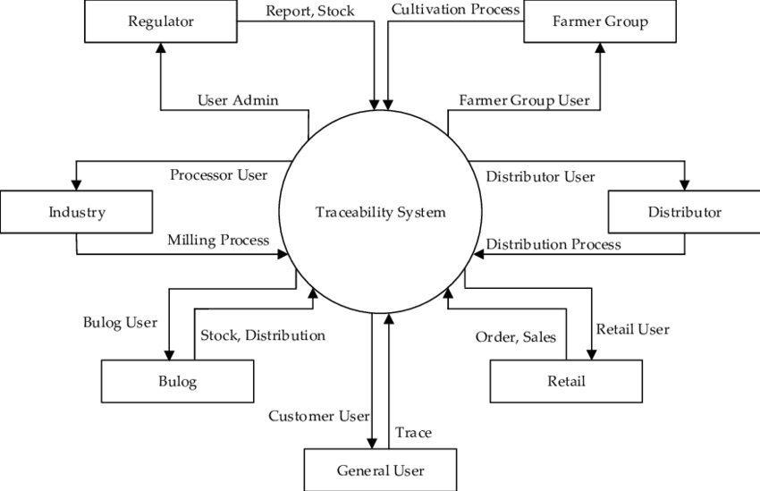

**User Stories**

Use the below template to list all the user stories for the product.

| **User Type** | **Functional Requirement (Epic)** | **User Story Number** | **User Story / Task** | **Acceptance criteria** | **Priority** | **Team Member** |
| --- | --- | --- | --- | --- | --- | --- |
| Customer (Mobile user) | Registration | USN-1 | As a user, I can register for the application by entering my email, password, and confirming my password. | I can access my account / dashboard | High | Shivam |
| Customer (Mobile user) | Registration | USN-2 | As a user, I will receive confirmation email once I have registered for the application | I can receive confirmation email & click confirm | High | Shivani |
| Customer (Mobile user) | Registration | USN-3 | As a user, I can register for the application through Facebook | I can register & access the dashboard with Facebook Login | Low | Shivam |
| Customer (Mobile user) | Registration | USN-4 | As a user, I can register for the application through Gmail | Sign-up | Medium | Shivam |
| Customer (Mobile user) | Login | USN-5 | As a user, I can log into the application by entering email & password | Login page | High | Sandeep |
| Customer (Mobile user) | Dashboard | UNS-6 | As a user , I can view my profile | Edit the profile | Medium | Shivam |
| Customer (Web user) | Web portal | UNS-7 | As a user , I can view and search the food types | give the order button | High | Sandeep |
| Customer Care Executive | Toll free number | UNS-8 | As a user , I can taste the food and give the review about the food | Quires | Low | Shivani |
| Administrator | Admin | UNS-9 | As a Admin Control all the data’s in the database | Controler | High | Sandeep |
|  |  |  |  |  |  |  |
|  |  |  |  |  |  |  |
|  |  |  |  |  |  |  |